Parent Display of Appreciation
$25

This required fundraiser is just one of the ways we offset the cost of the venue and other expenses having to do with the production. Please email a picture of your student to Hannah at hannah.ferguson@live.com with your student’s name in the subject line.
Due by ________
PDA Information:
Student Name: ____________________________________________________
What would you like to say? You can email me this portion with your student’s picture if you would like!
________________________________________________________________________________________________________________________________________________________________________________________________________________________________________________________________________________________________________________________
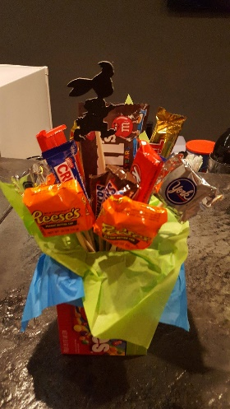
Extras:
- Bouquet $15
- Candy Gift Basket $15

Total Cost: ___________________
Cash Card Check

For office use, only:
Date received: ________ Signature: ______________________
Date paid: ____________ Signature: _______________________

